**CENWP-OD-*D 6/8/2022***

**MEMORANDUM FOR THE RECORD *22TDA09***

**SUBJECT: *Gatewell salmonid mortality***

*On Jun8, while doing gatewell inspection a salmonid mortality was observed inside a cross support of a bulkhead in gatewell 9-1. It appears to have become stranded as water level receded. This is a rare occurrence in these locations. Speculation is this could be a result of recent very rapid forebay fluctuations seen daily.*

1. Species –appears Chinook from distance
2. Origin –NA
3. Length –NA
4. Marks and tags –NA
5. Marks and Injuries found on carcass –NA
6. Cause and Time of Death – likely stranding
7. Future and Preventative Measures –no changes planned at this time.

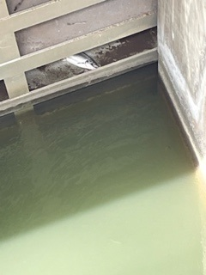

Sincerely,

Project Fisheries